### **Project Report: E-Commerce Store Builder**

**Student Name:** Zohaib, Aqsa  
**Project Title:** E-Commerce Store Builder  
**Course:** DISM  
**Instructor:** Sir Wali Muhammad  
**Date:** July, 8, 2024

**Project Overview:**

The E-Commerce Store Builder project aims to create a platform similar to Wix and Shopify, allowing users with no coding experience to easily create and customize their e-commerce stores. The project is developed with a focus on simplicity and user-friendliness, ensuring that even a child can navigate and use the interface.

**Key Features and Functionality:**

**1. User-Friendly Drag-and-Drop Builder:**

* **Basic Interface:**
  + Utilizes JavaScript libraries like jQuery UI to implement simple drag-and-drop functionality.
* **Element Customization:**
  + Provides basic options for customizing elements such as text, images, buttons, and product listings.

**2. Pre-Designed Templates:**

* **Template Gallery:**
  + Includes a selection of simple, responsive templates for users to choose from.
* **Basic Customization:**
  + Allows users to change colors and fonts using CSS, ensuring a personalized look and feel.

**3. Product Management:**

* **Add/Edit/Delete Products:**
  + Implements simple PHP forms to manage product listings effectively.
* **Product Categories:**
  + Organizes products into categories using a straightforward database structure.

**4. Integrated Payment Gateways:**

* **Payment Setup:**
  + Integrates with PayPal for straightforward payment processing.
* **Basic Payment Options:**
  + Enables customers to complete transactions using PayPal.

**5. SEO Tools:**

* **Basic SEO Settings:**
  + Provides options to add meta titles and descriptions to store pages, enhancing search engine visibility.
* **SEO Guidance:**
  + Offers basic tips for optimizing store content for better search engine ranking.

**6. Mobile-Friendly Design:**

* **Responsive Templates:**
  + Ensures all templates are mobile-responsive using frameworks like Bootstrap.
* **Preview Mode:**
  + Includes a simple toggle feature to preview the store on different devices.

**7. User Dashboard:**

* **Sidebar Navigation:**
  + Contains sections for adding elements, themes, settings, and help.
* **Main Canvas:**
  + Features a central area for building and customizing the store with drag-and-drop functionality.
* **Top Bar:**
  + Displays options for saving, publishing, undoing, redoing actions, and accessing user profiles.

**8. Store Settings:**

* **General Settings:**
  + Configures store name, uploads logos, and adds store descriptions.
* **Payment Integration:**
  + Manages PayPal as the primary payment method.

**9. Help and Support:**

* **Basic Tutorials:**
  + Provides simple guides for common tasks and features to assist users.
* **FAQs:**
  + Lists frequently asked questions with clear, straightforward answers.
* **Contact Support:**
  + Features a basic contact form for user queries and support requests.

**10. Security and Performance:**

* **Basic Security:**
  + Implements essential security measures, including input validation and secure password storage using password_hash.

**Optional Advanced Features (If Time Permits):**

**11. Analytics and Reporting:**

* **Sales Reports:**
  + Develops simple PHP scripts to view sales data and performance metrics.
* **Traffic Analytics:**
  + Integrates Google Analytics to monitor website traffic.

**12. User Account Management:**

* **Profile Settings:**
  + Manages user profiles, account settings, and preferences.
* **User Roles:**
  + Implements basic user roles for administrators and customers.

**Tools and Technologies:**

* **PHP:** Backend development and server-side scripting.
* **MySQL:** Database management.
* **JavaScript/jQuery:** Frontend interactivity and drag-and-drop functionality.
* **Bootstrap:** Responsive design and easy styling.
* **PayPal API:** Payment processing.
* **Google Analytics:** Traffic analysis.

**Conclusion:**

The E-Commerce Store Builder project is designed to provide a comprehensive, user-friendly platform for creating and managing online stores. By focusing on simplicity and leveraging tools and technologies suitable for a student with basic PHP knowledge, this project aims to deliver a functional and accessible solution for small business owners and individuals looking to establish an online presence.

Here’s our project design:

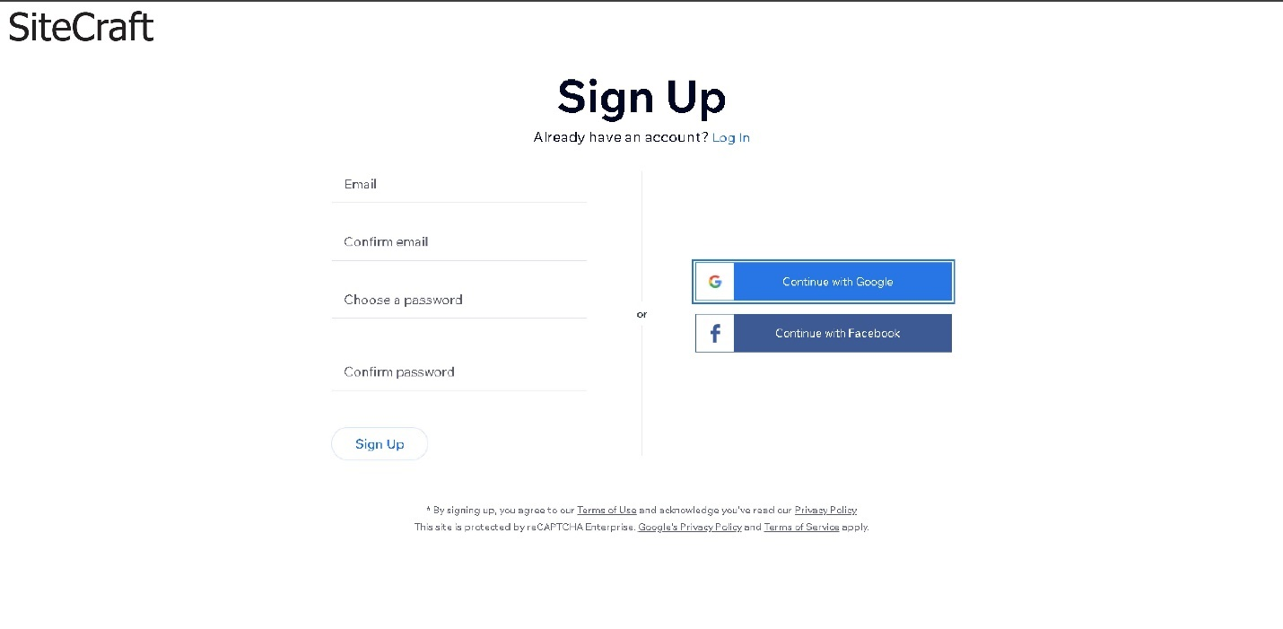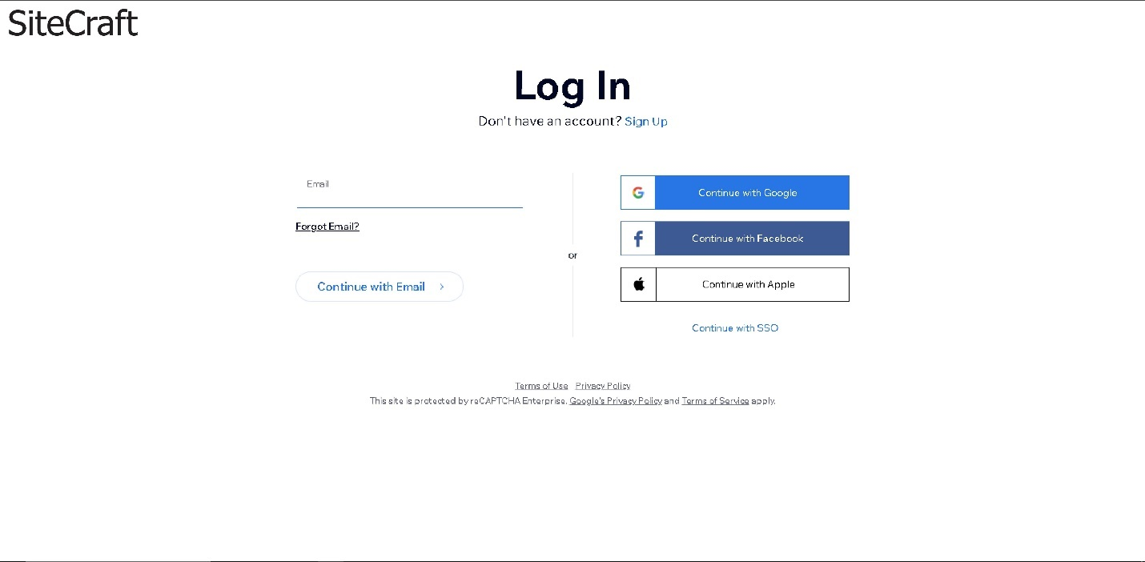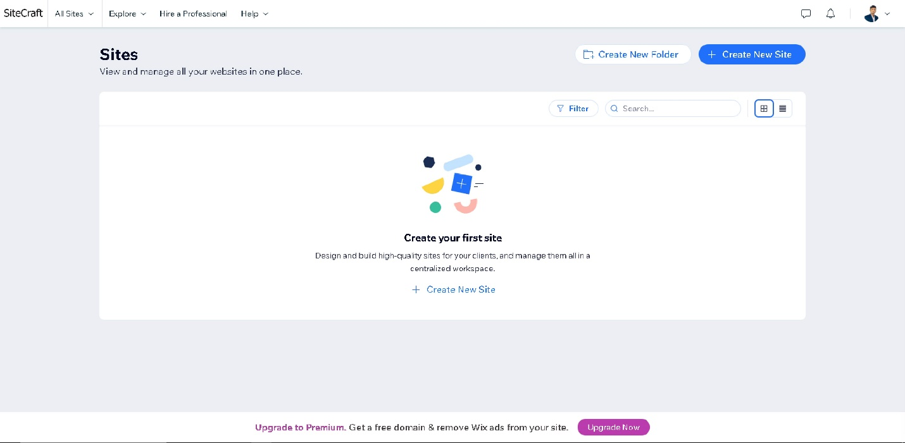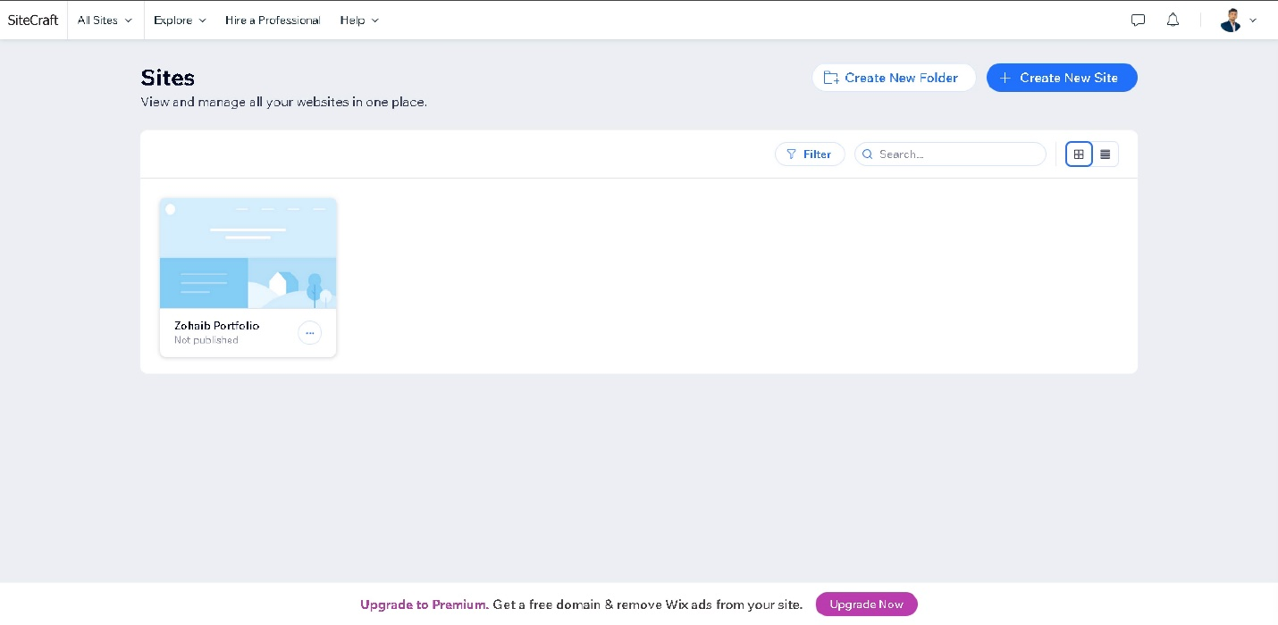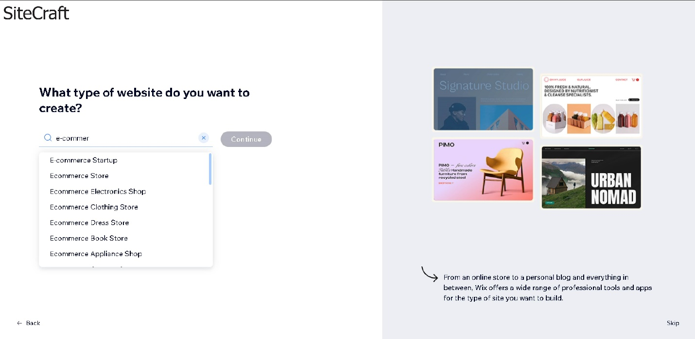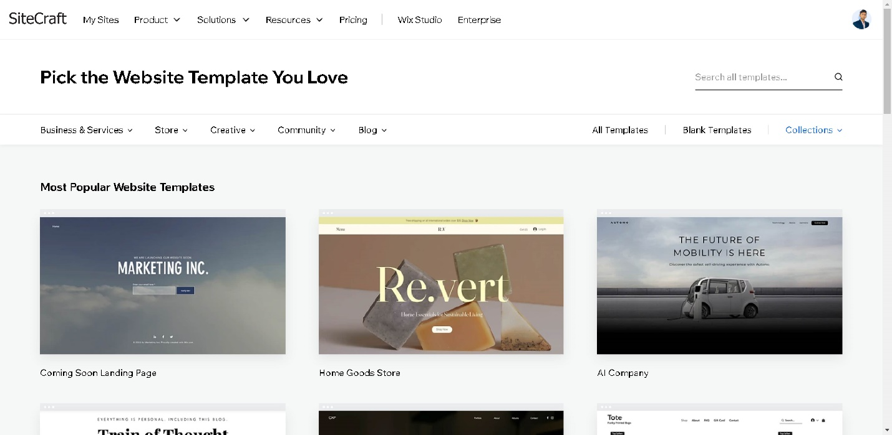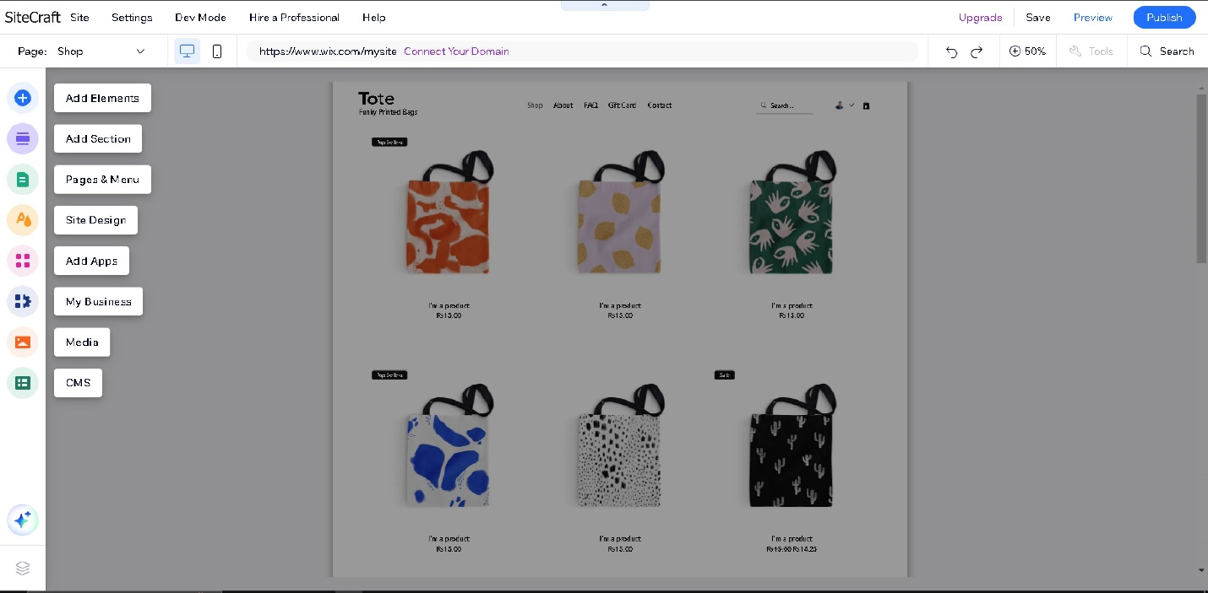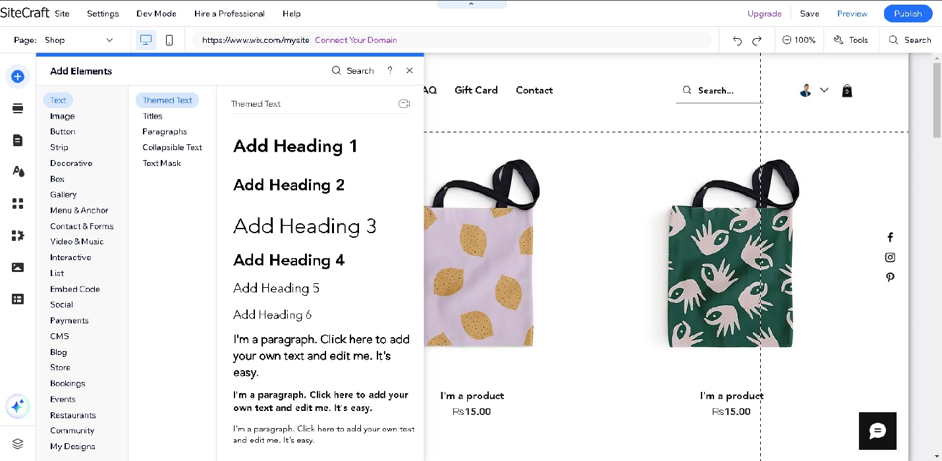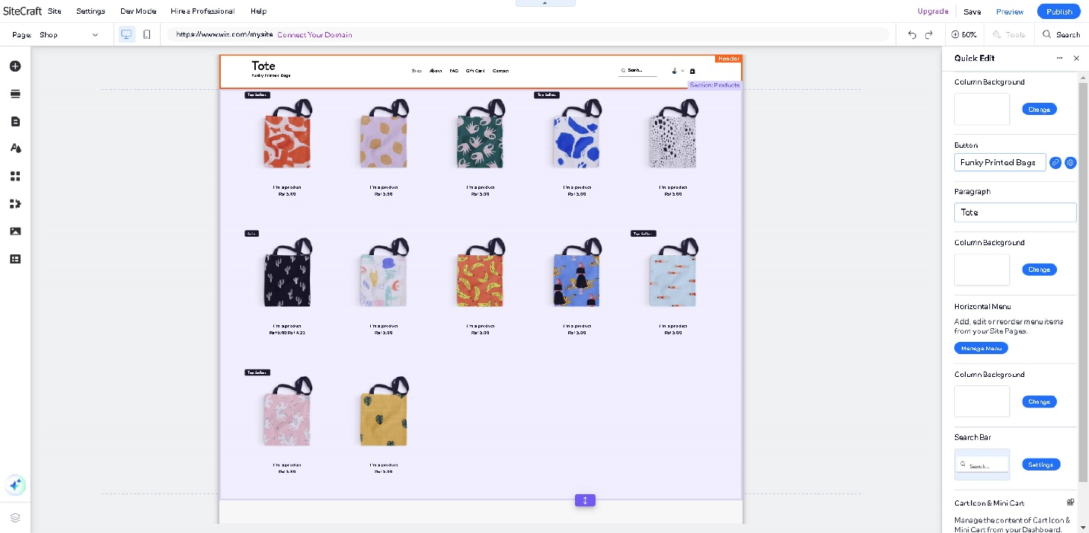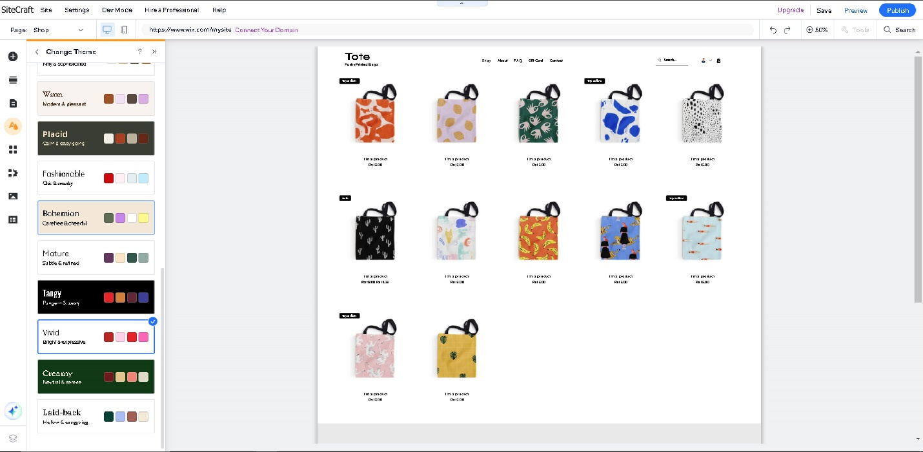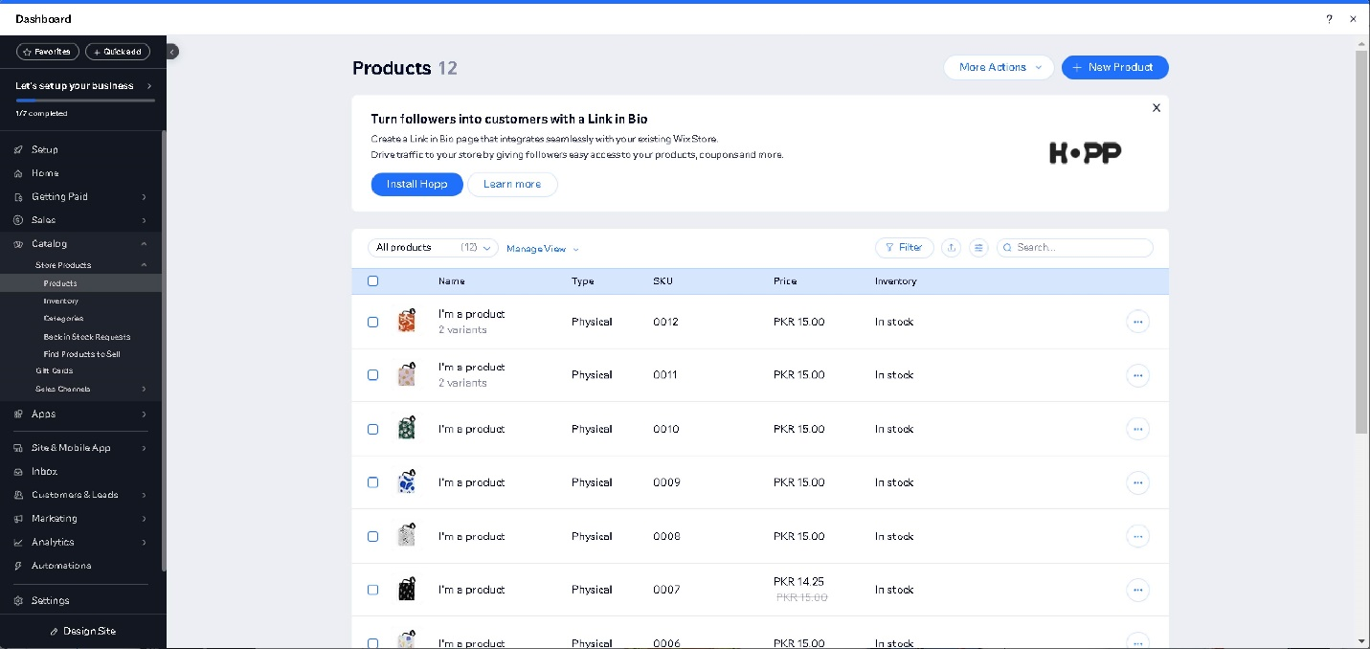

Thank you for you time.